**Model Development Phase Template**

|  |  |
| --- | --- |
| Date | 5 May 2024 |
| Team ID | 737906 |
| Project Title | Walmart Sales Analysis for Retail Industry with Machine Learning |
| Maximum Marks | 4 Marks |

**Initial Model Training Code, Model Validation and Evaluation Report**

The initial model training code will be showcased in the future through a screenshot. The model validation and evaluation report will include classification reports, accuracy, and confusion matrices for multiple models, presented through respective screenshots.

**Initial Model Training Code:**

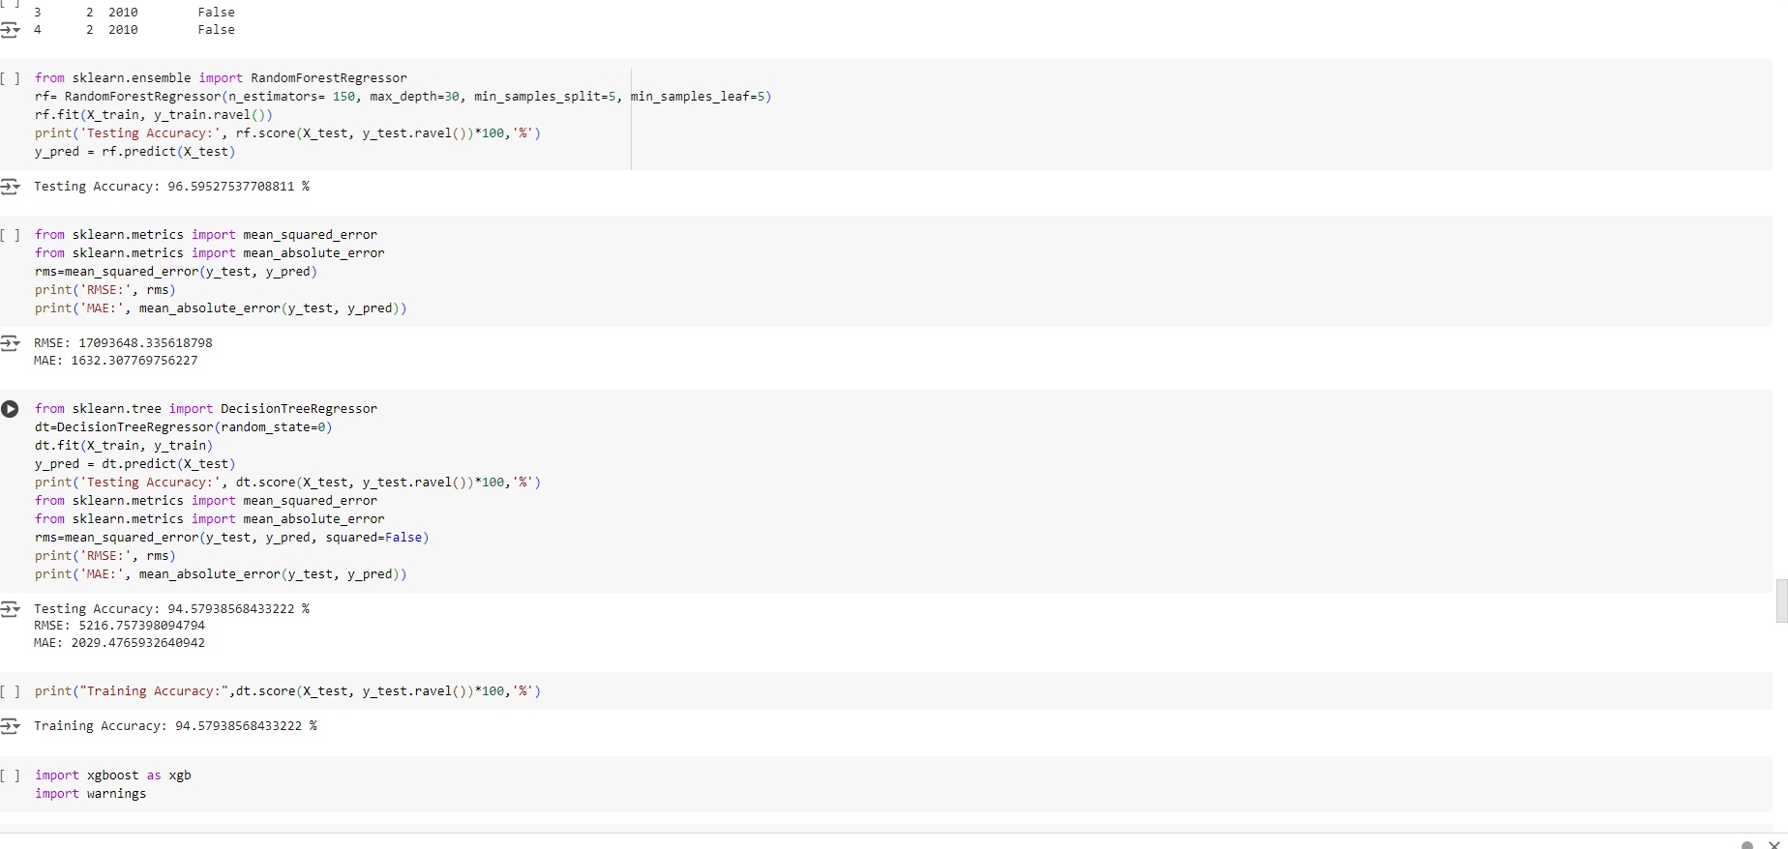

**Model Validation and Evaluation Report:**

|  |  |  |
| --- | --- | --- |
| **Model** | **Classification Report** | **Accuracy** |
| Random Forest |  | 94% |
| Decision Tree |  | 100% |
| XgBoost |  | 94% |
| ARIMA |  |  |